List of equipment and samples needed:

- Loupe
- Straight edge to use for dissection (razor blade, exacto knife) and cutting surface
- Flowers
  - A compositae flower
    - Examples include: gerbera, aster, or any daisy like flower
  - A perfect flower
    - Examples include: Alstroemeria, fuchia, Cistus, Asiatic Lily, old fashion rose, Geranium - not pelargonium , but the five petaled simpler flower, or any flower where you can see all of the flower parts
  - Any “stranger” flowers you want to take a closer look at.
- Any first aid equipment you think you will need (bandages, etc)
- This entire document

FLOWER VOCABULARY
Please review and know these terms:

- Anther
- Bract
- Calyx
- Complete flower
- Corolla
- Determinate or Indeterminate
- Dioecious or Monecious
- Filament
- Perfect or Imperfect
- Inflorescence
- Ovary
- Panicle
- Pedicel
- Peduncle
- Perianth
- Petals
- Pistil
- Pollen
- Receptacle
- Sepals
- Spadix
- Spike
- Stamen
- Staminate
- Stigma
- Style
- Tepals
- Umbel

Flower review worksheet
Please label this worksheet and relate to your flower

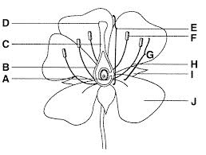

A
B
C
D
E
F
G
H
I
J

